NAME : CH.Srikruthi

ROLLNO: 2403A510H0

BATCHNO: 06

Task 1 – Por olio Website Design

You are building a personal por olio website to showcase your work.

Requirements:

* Create sec ons for About Me, Projects, and Contact.
* Use AI to:

o Suggest color pale es and typography. o Create a responsive layout with Grid/Flexbox. o Add smooth scrolling naviga on.

PROMPT:

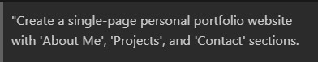

CODE:

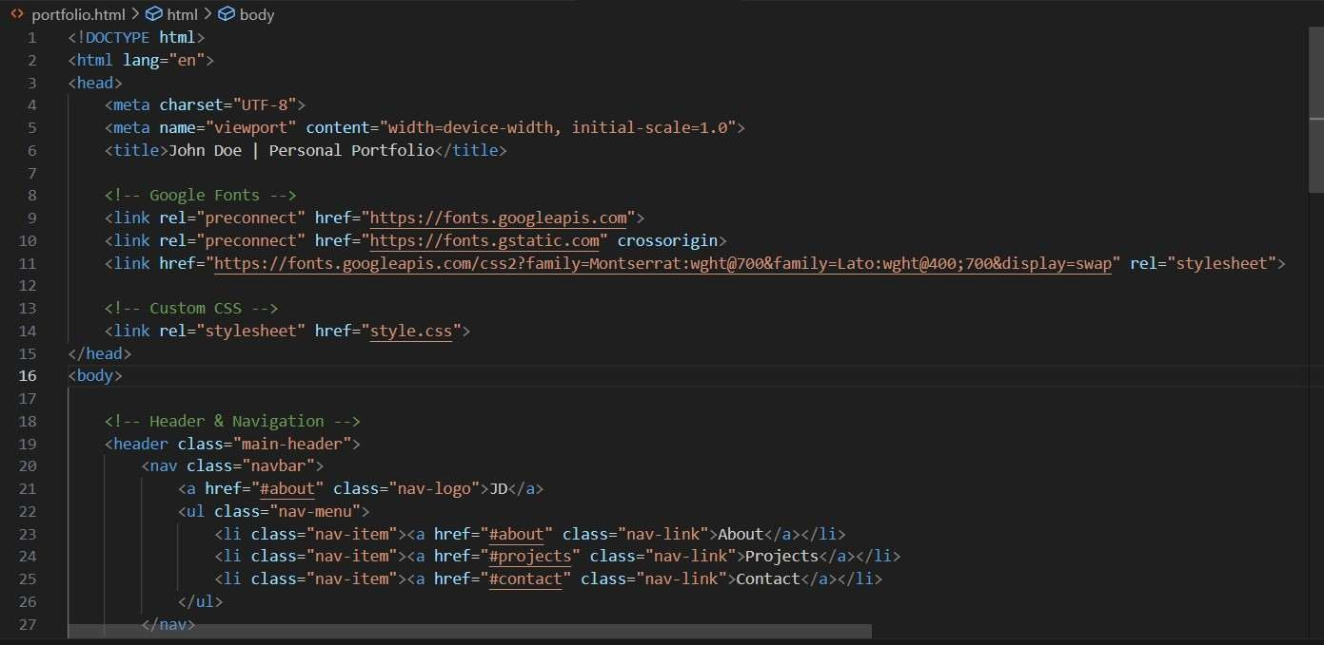

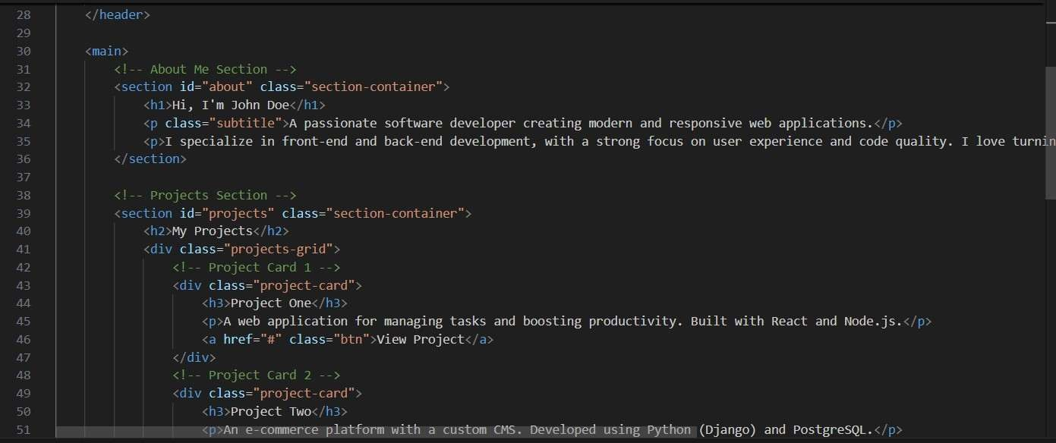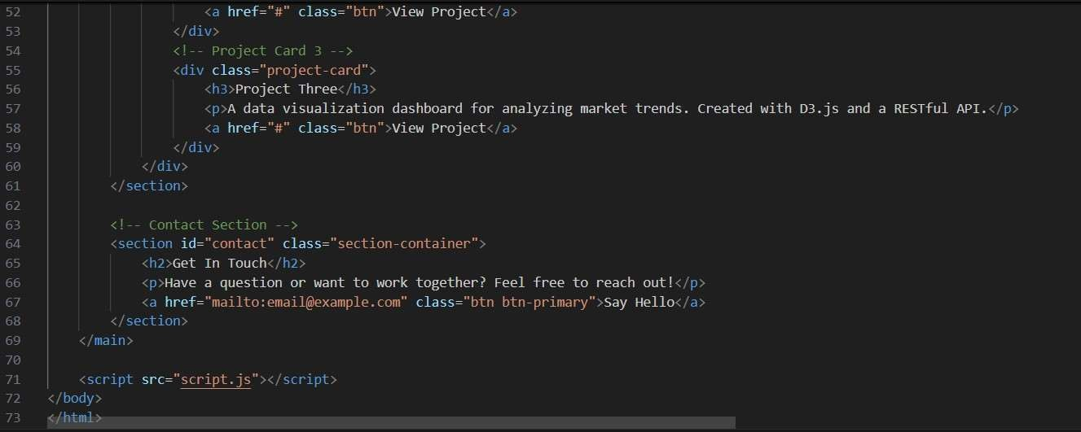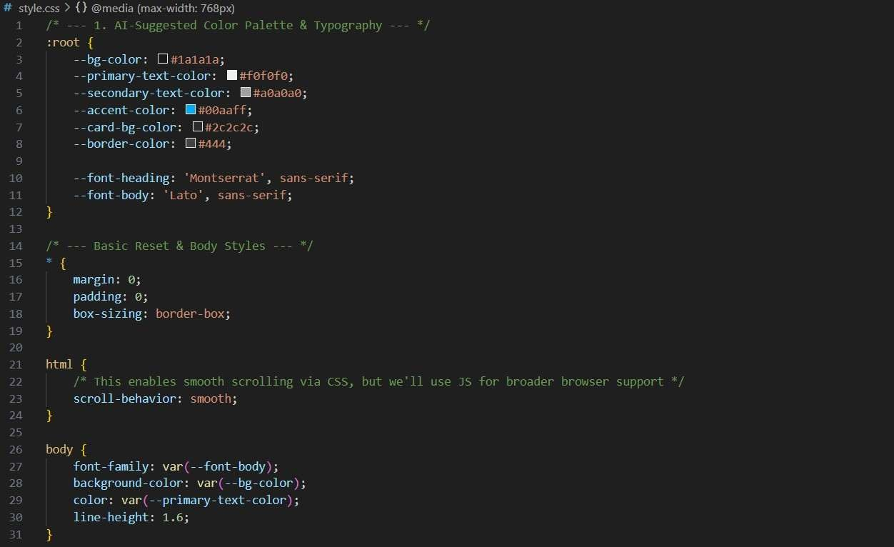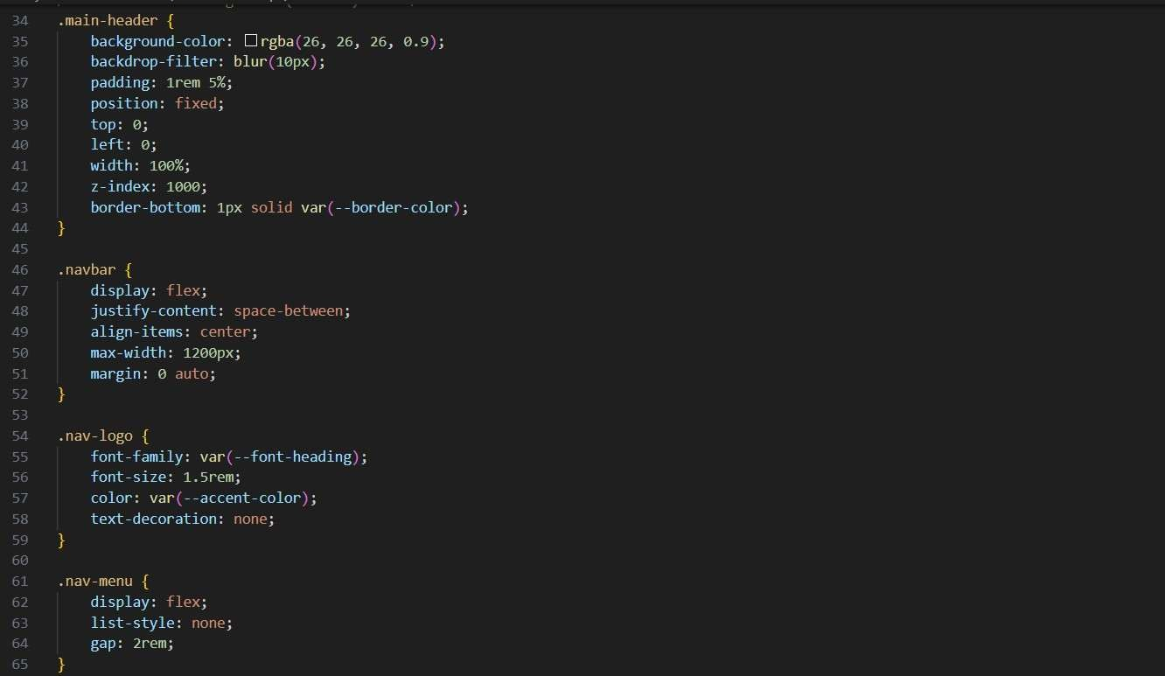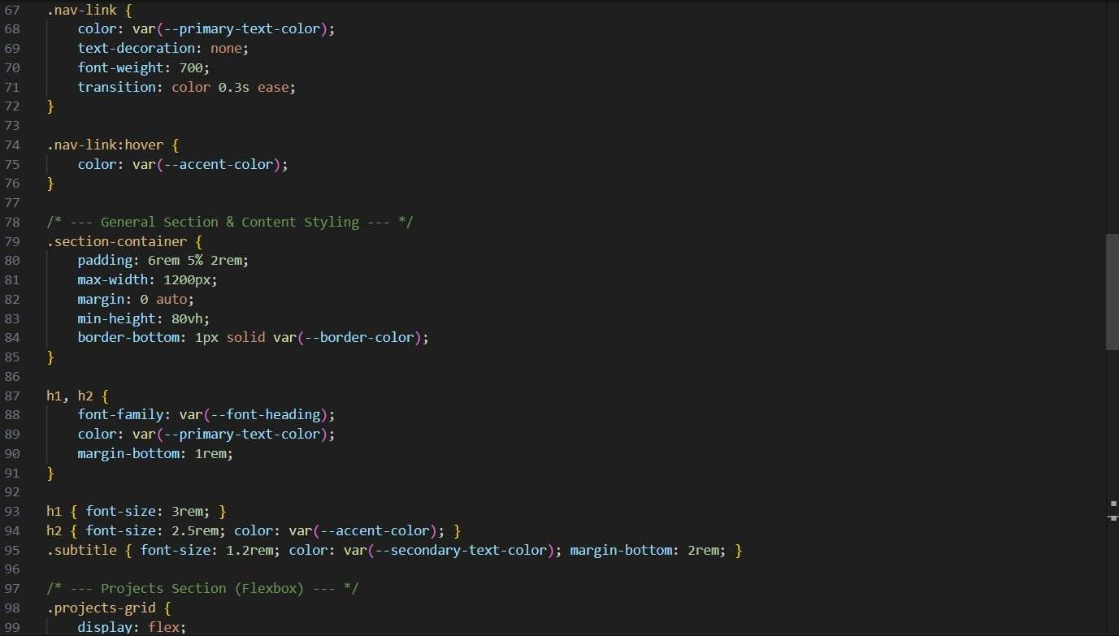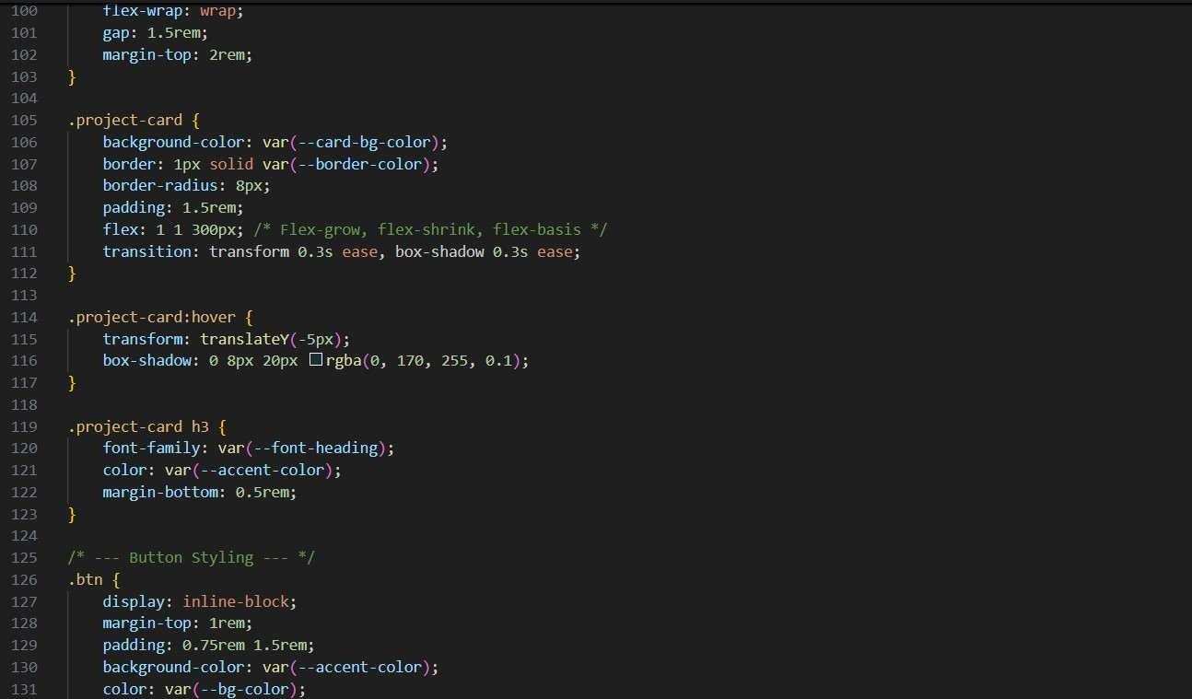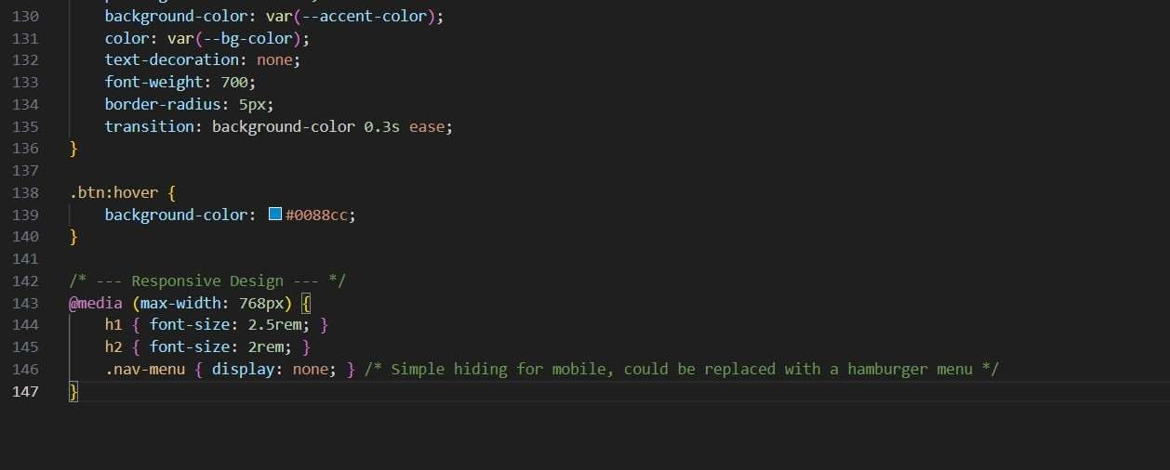

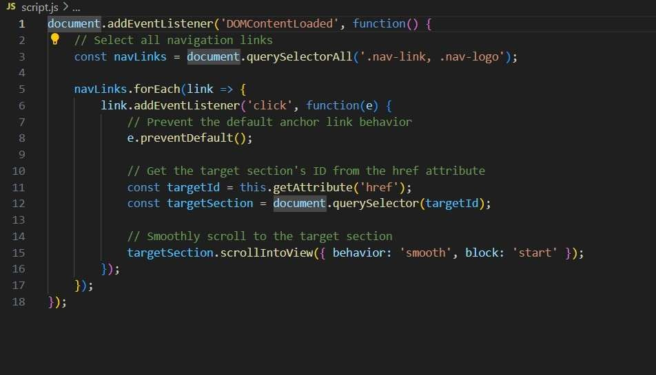

OUTPUT:

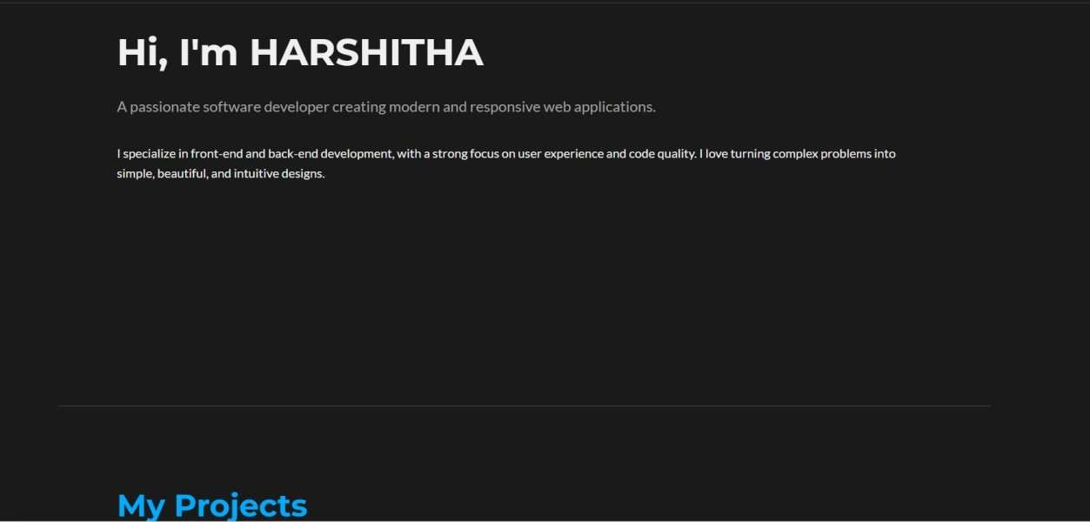

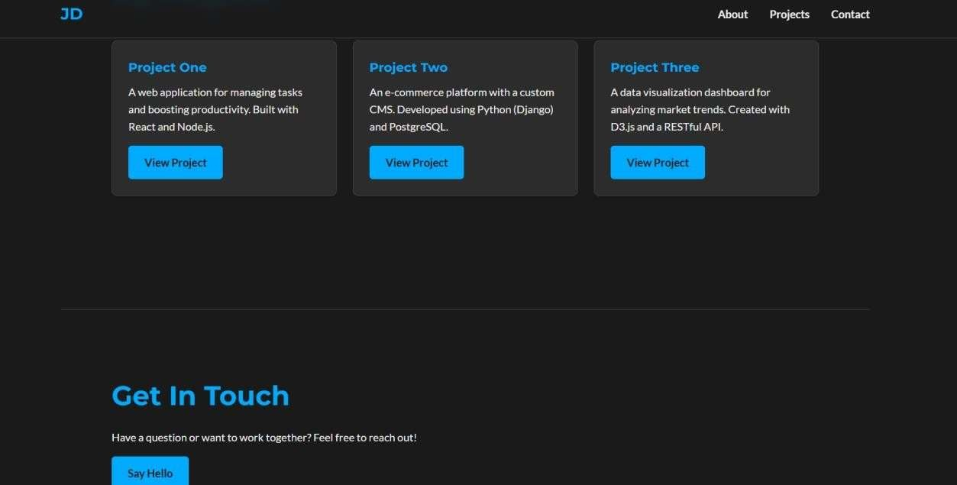

OBSERVATION:

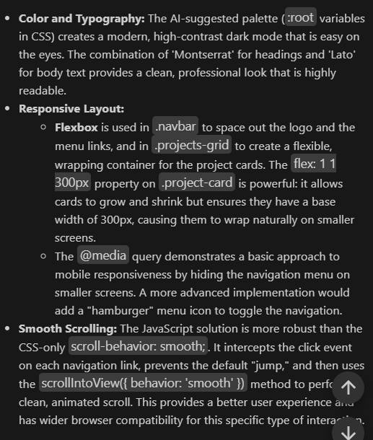

Task 2 – Online Store Product Page

Design a product display page for an online store.

Requirements:

* Display product image, tle, price, and "Add to Cart" bu on.
* Use AI to:

o Style with BEM methodology. o Make layout responsive. o Add hover effects and "Add to Cart" alert.

PROMPT:

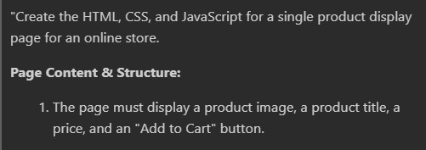

CODE:

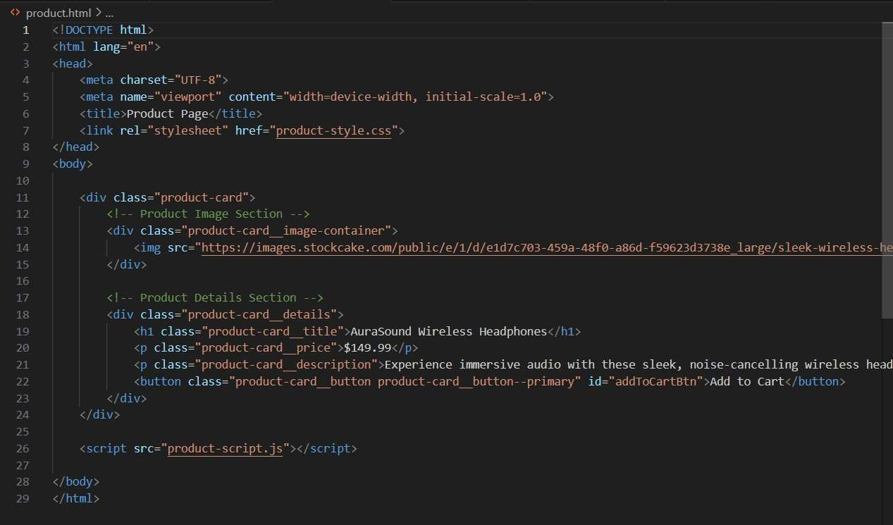

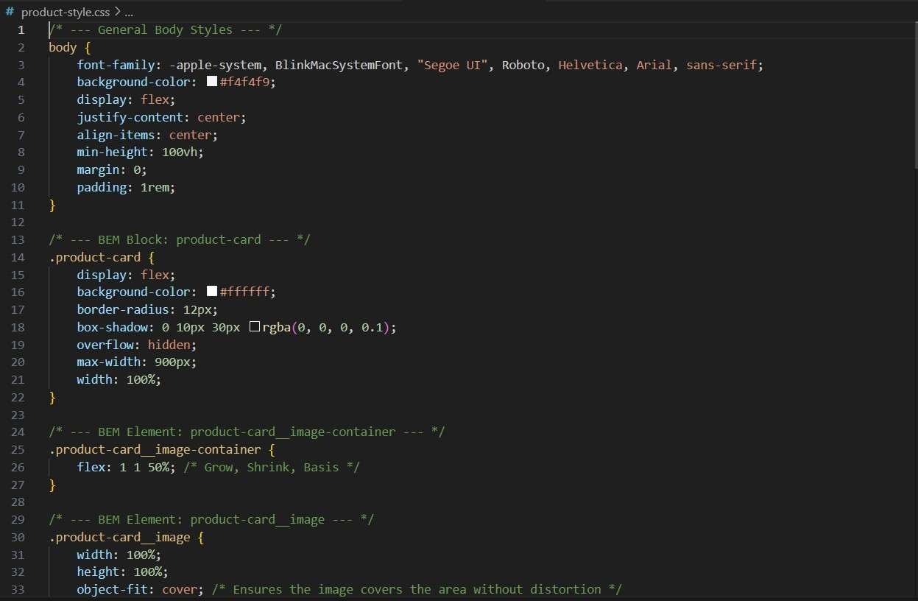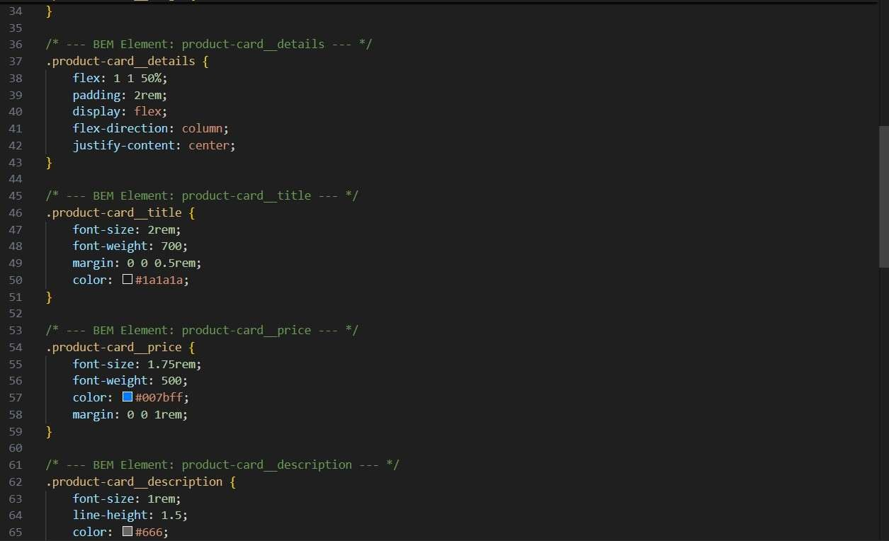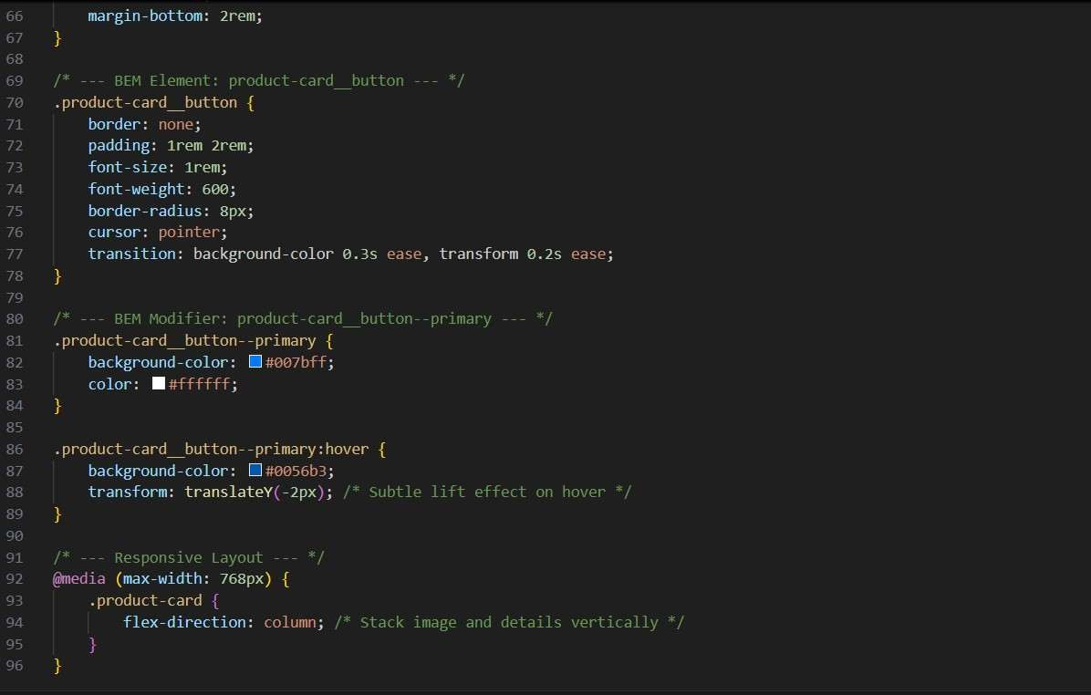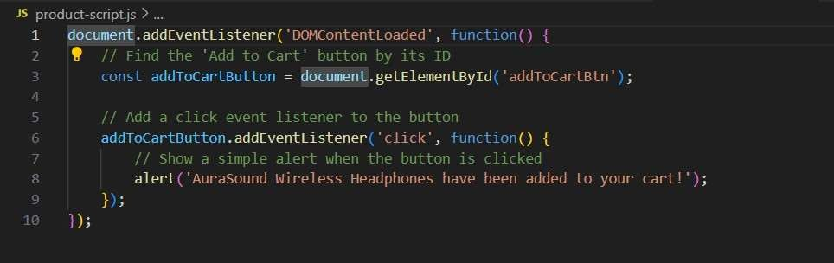

OUTPUT:

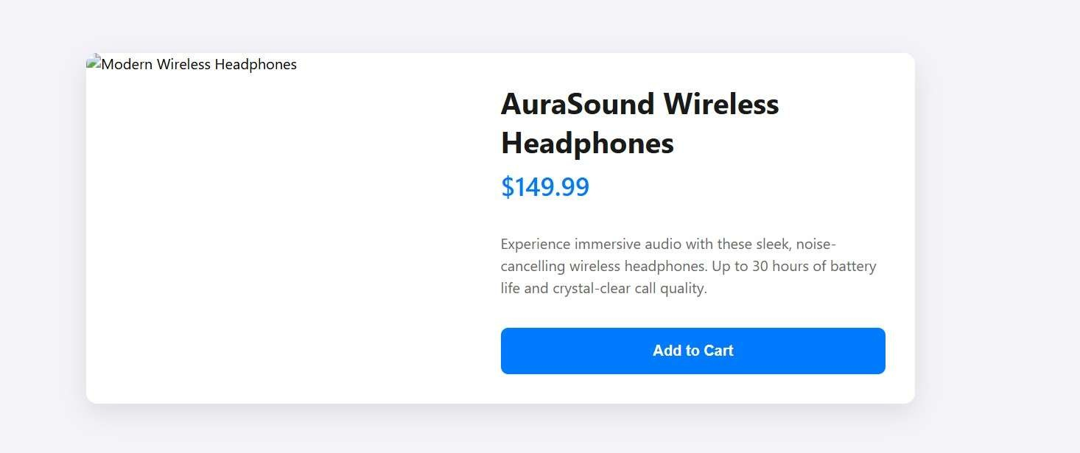

OBSERVATION:

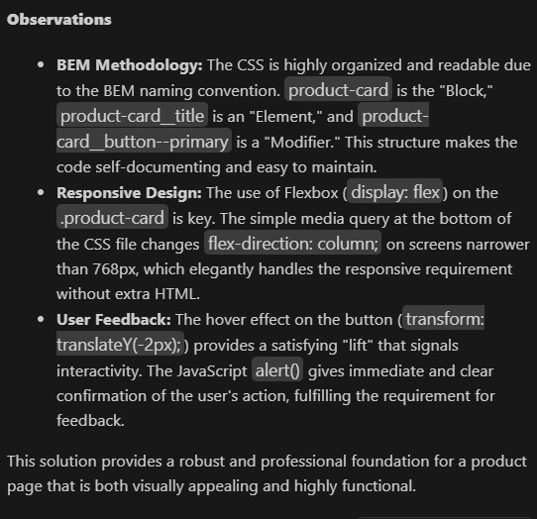

Task 3 – Event Registra on Form

Build an event registra on form for a conference.

Requirements:

* Collect name, email, phone number, and session selec on.
* Use AI to:

o Add form valida on with JavaScript. o Make the form accessible with labels and ARIA. o Style with a professional look.

PROMPT:

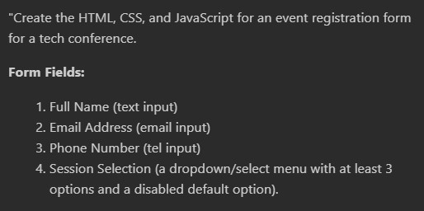

CODE:

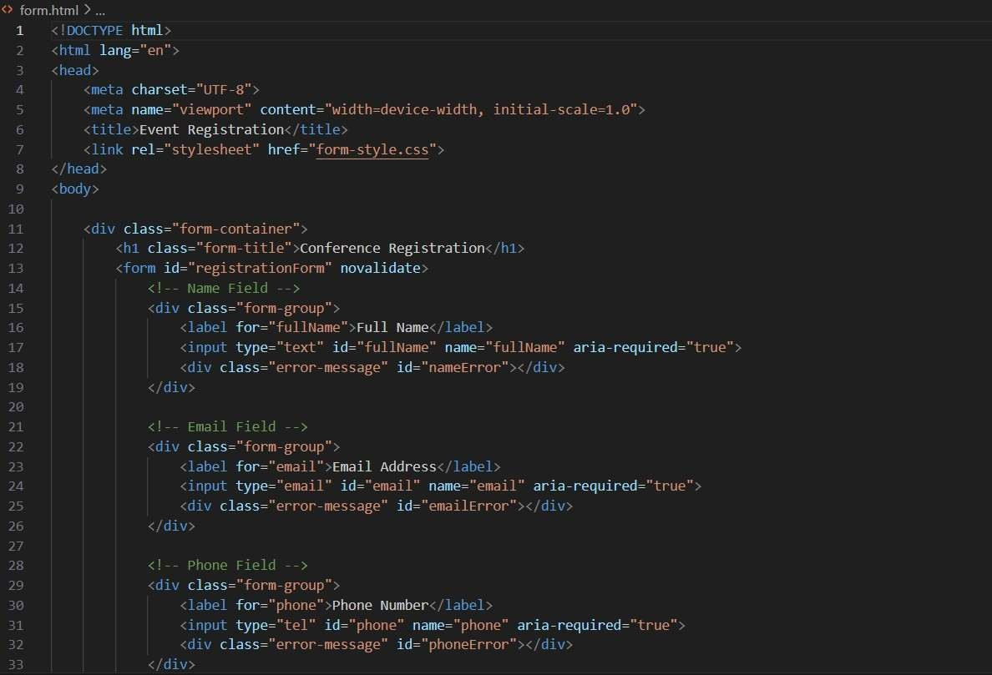

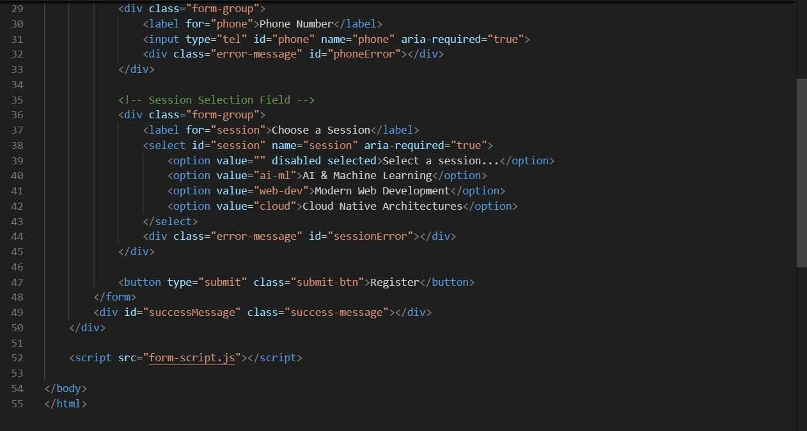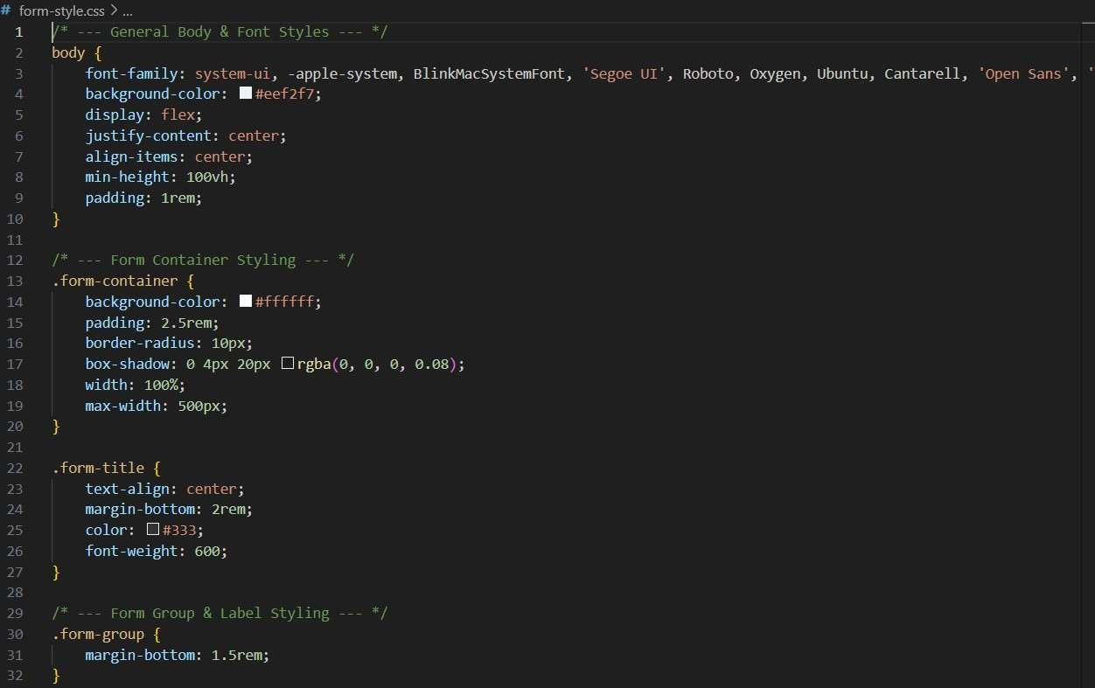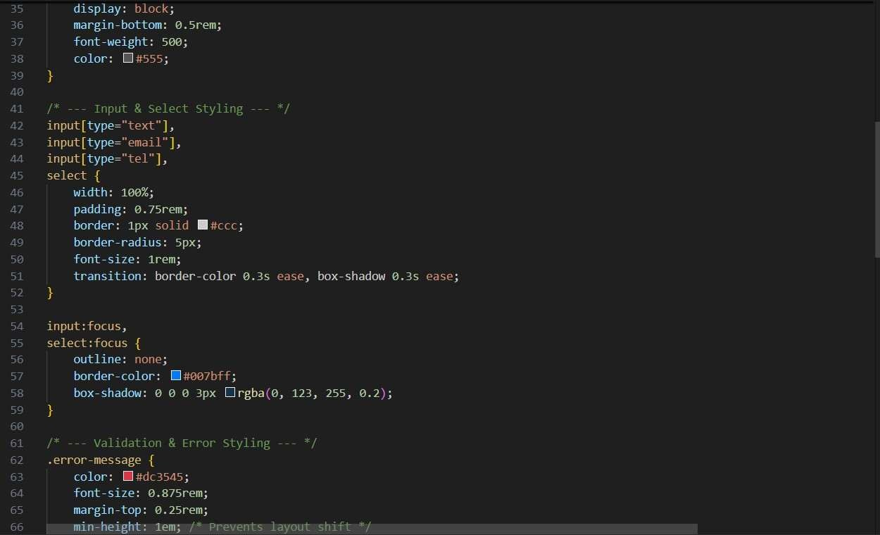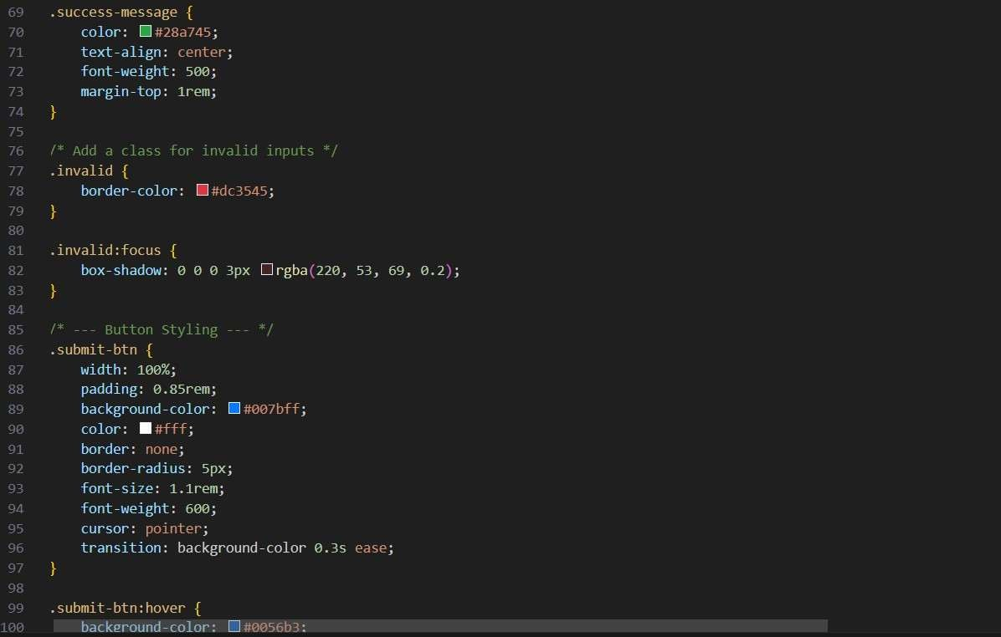

OUTPUT:

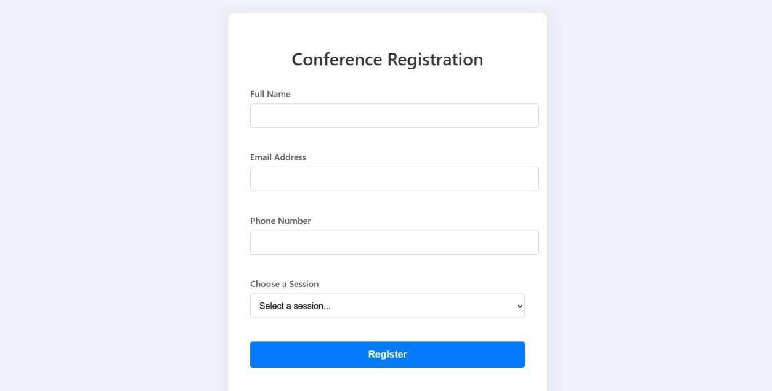

OBSERVATION:

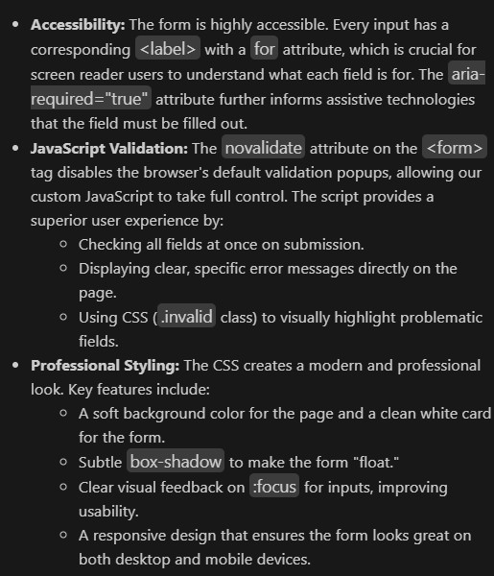

Task Descrip on #4 (Data – Fetch API & Render List with

Loading/Error States)

* Task: Fetch JSON from an API and render items to the DOM with loading and error UI.
* Instruc ons: o Ask AI to write fetch() logic, create DOM nodes safely, and add skeleton/loading text.

Deliverables (For All Tasks)

1. AI-generated prompts for code and test case genera on.
2. At least 3 assert test cases for each task.
3. AI-generated ini al code and execu on screenshots.
4. Analysis of whether code passes all tests.
5. Improved final version with inline comments and explana on.
6. Compiled report (Word/PDF) with prompts, test cases, asser ons, code, and output.

PROMPT:

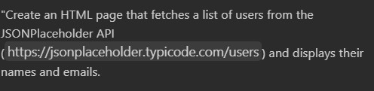

CODE:

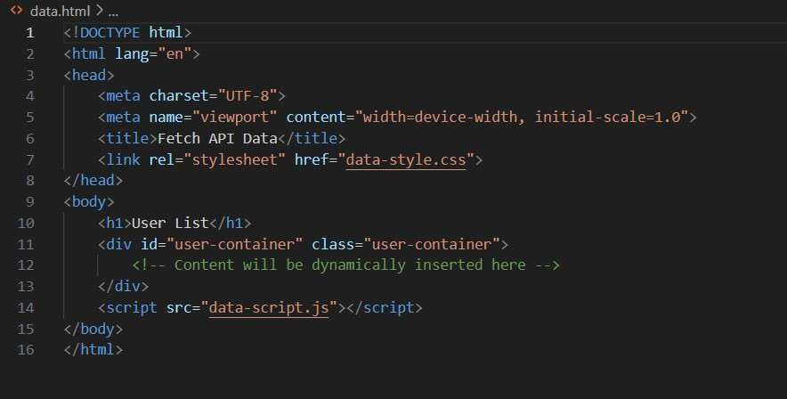

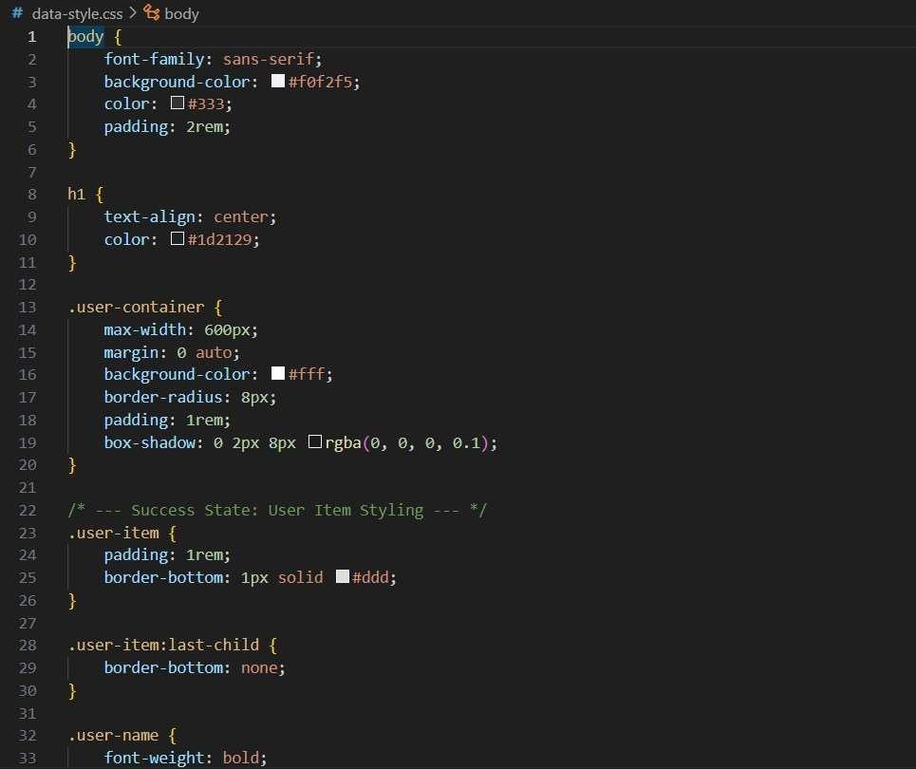

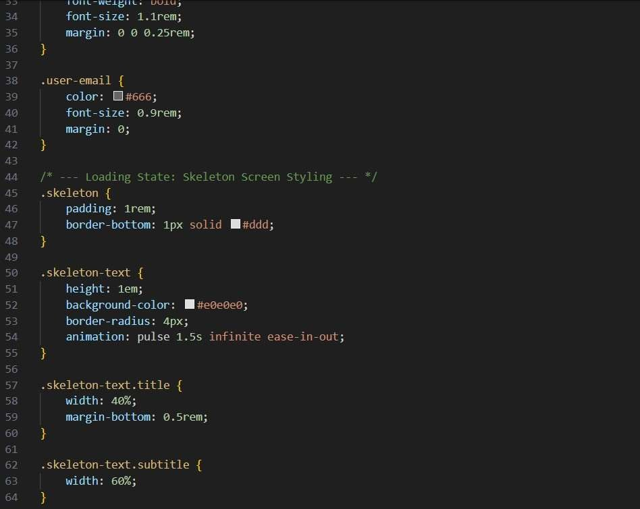

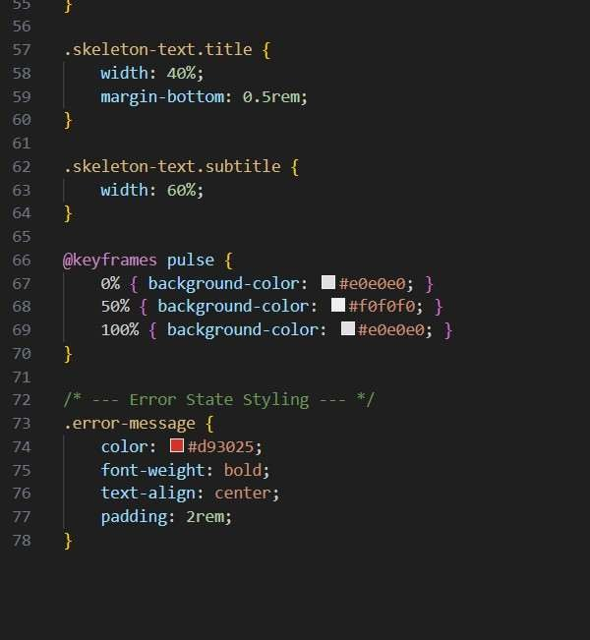

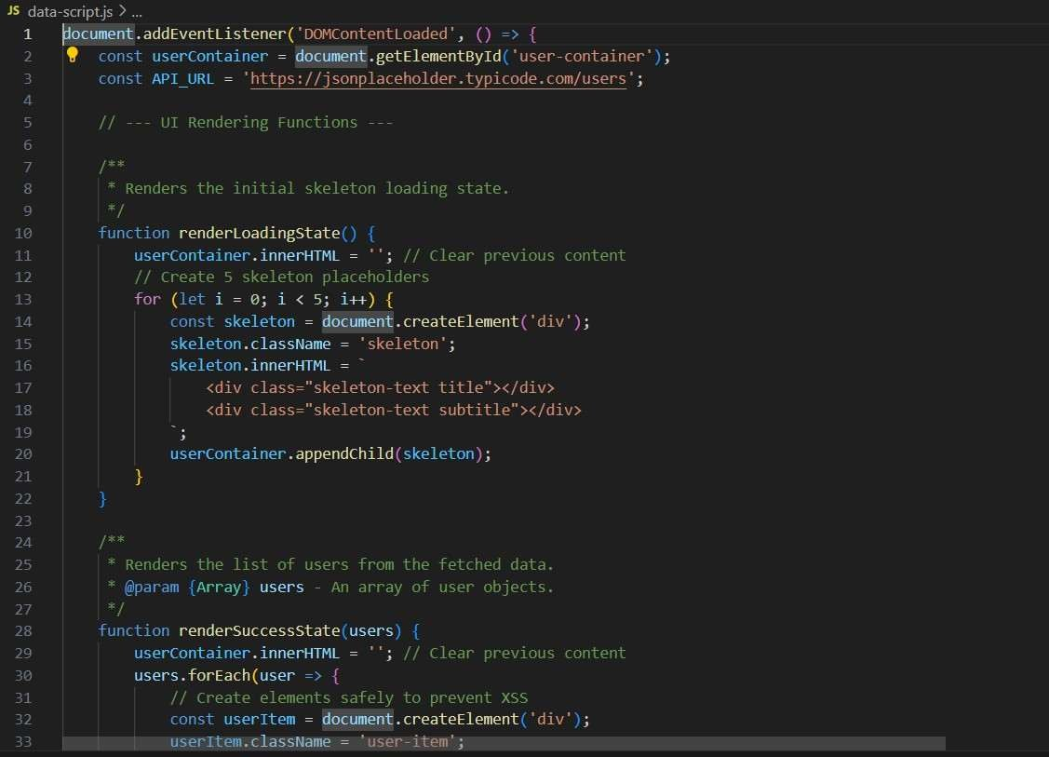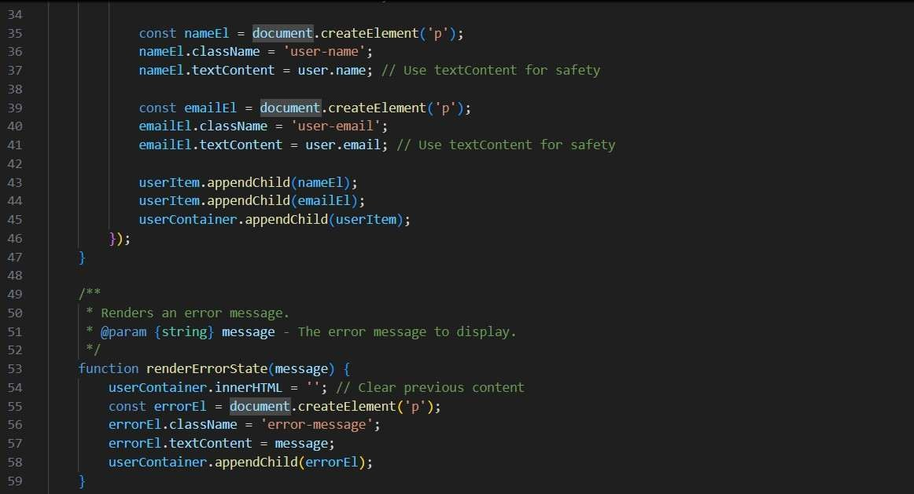

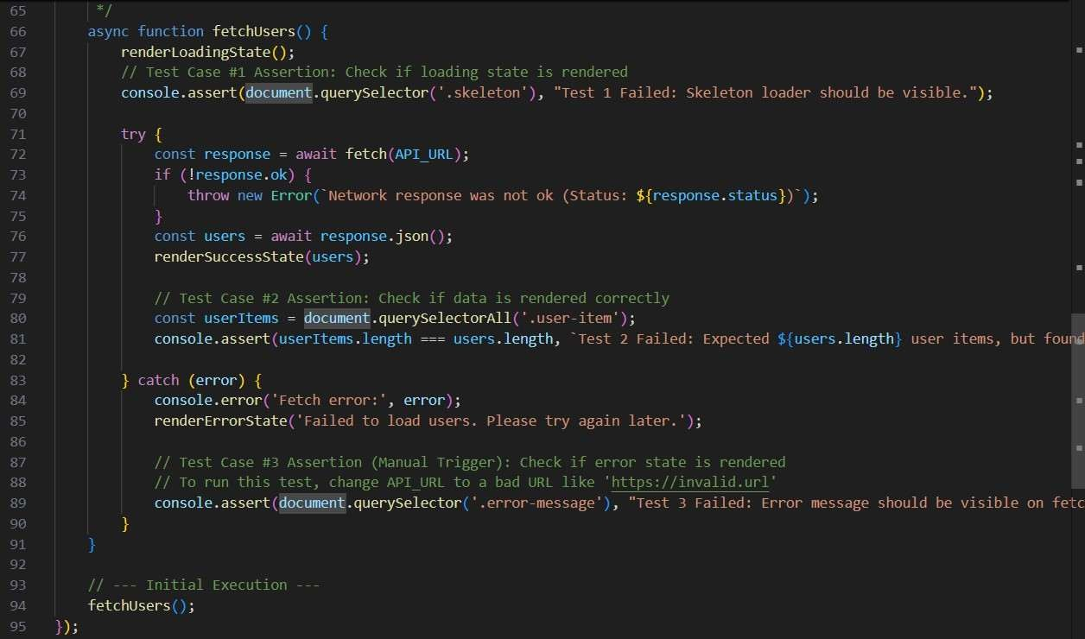

OUTPUT:

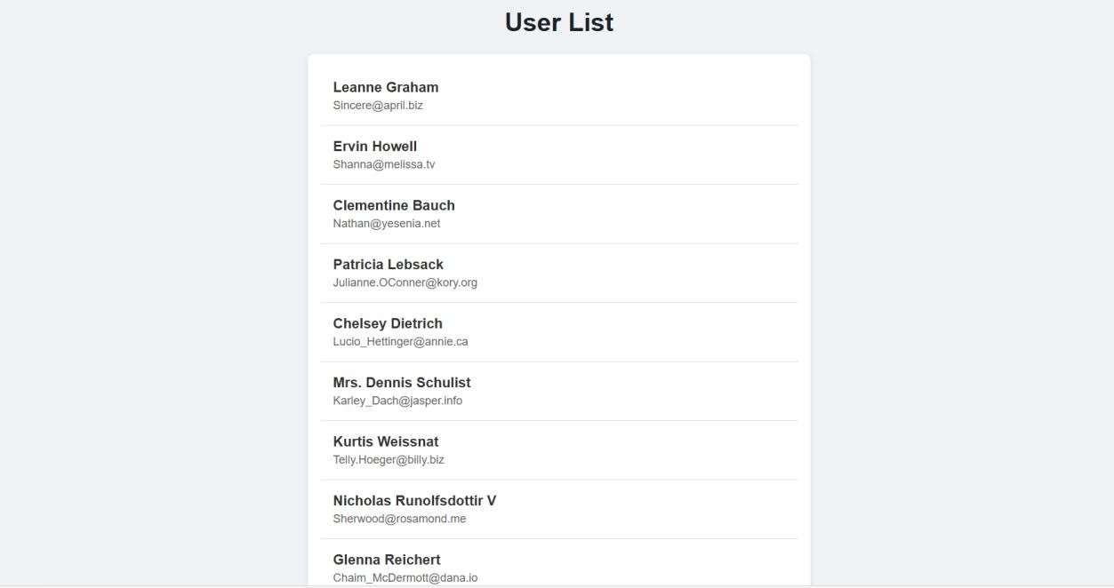

Observa on:

